ADSafeVANET & Privacy concerns

1. Privacy in ITS 1
1.1 ITS registration - obtaining Butterfly keys 2
1.2 Communication between ITS stations 2
1.2.1 Common structures 2
1.2.1.1 signedData or EtsiTs103097Data-Signed 3
1.2.1.2 ToBeSignedData 3
1.2.1.3 EncryptedData 4
1.3 Changing pseudonyms (VERY IMPORTANT) 4
1.3.1 Changes in the CAM messages 6
1.4 Data Encryption and Decryption 7

Privacy in ITS

ITS Privacy is assured in two forms:
- Privacy of ITS registration and authorization tickets (butterfly keys)
  - Ensure that only a limited set of Enrolment Authorities have access to the canonical identifier of an ITS-S
  - The separation of duties in the PKI infrastructure is relevant to ensure that only EAs have access to canonical identifiers, while the AA is responsible to authorize and manage services.
- Privacy of communications between ITS stations

ITS registration - obtaining Butterfly keys
To implement privacy in VANETs one of the first aspects to consider is the use of pseudonyms that are specified in ETSI TS 102 941 and IEEE 1609.2.1 standards.
The butterfly keys correspond to a set of short-term authorization tickets (ATs) that are requested in a single request and can be downloaded asynchronously. Figure 1 illustrates the involved entities in the process of requesting Butterfly keys, and it considers:
- ITS-S a vehicle with capabilities of communication (ITS Station)
- An Enrolment Authority (EA), which receives the request from ITS-S
- The Authorization Authority (AA) which will generate the set of butterfly keys
All the messages exchanged between these entities are signed.
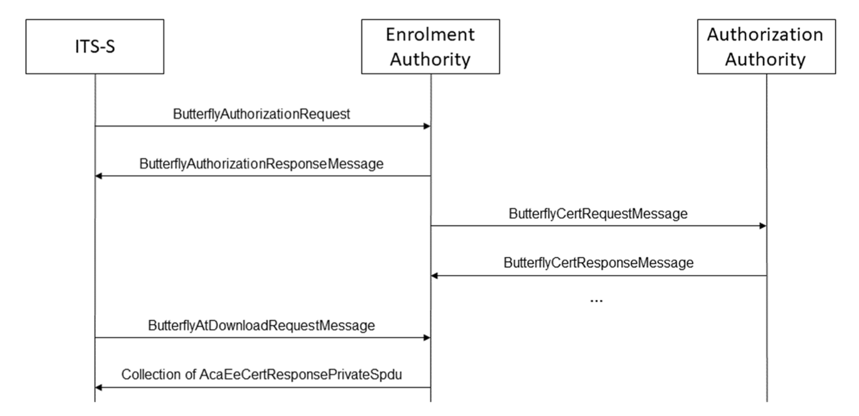
Figure 1 - Requesting Butterfly keys (as per ETSI TS 102 941)

Communication between ITS stations

Common structures
The messages follow the structures specified in IEEE 1609.2 standard https://forge.etsi.org/rep/ITS/asn1/ieee1609.2/-/raw/v2025/Ieee1609Dot2.asn

The broadcast applications, as per Broadcast Security Associations (SAs) are specified in Table XX.
Application / Service | Purpose | Security requirements
CA Basic Service |  | Authentication, authorization, integrity
DEN basic service |  | Authentication, authorization, integrity
CAM | Cooperative Awareness Messages | Signature verification as per ETSI TS 103 097
DENM |  | Signature verification as per ETSI TS 103 097

The security profile of CAMs include a secure data structure, as per ETSI TS 103 097 – EtsiTs103097Data-Signed, that is a type of SignedData (section 5.1 ETSI TS 103 097) which includes several fields as depicted in Tables XX and XXX.

signedData or EtsiTs103097Data-Signed
Table 1 - signedData type
Components | Subcomponent | Component description
Hashid |  | Hash algorithm
tbsData |  | ToBeSignedData content - paylod
Signer (SignerIdentifier) | digest
Signer (SignerIdentifier) | certificate
signature
headerInfo | tbsdata.headerInfo

ToBeSignedData
Table 2 - ToBeSignedData type
Components | Sub-Component | Component description
headerInfo | psID | ITS-AID (application identifier)  CAM, DENM values as per ETSI TS 102 965
 | generationTime
 | expiryTime
 | generationLocation | Not mandatory
 | p2pcdLearningRequest | Absent
 | missingCrlIdentifier | Absent
 | encryptionKey | Not mandatory (depends)
 | inlineP2pcdRequest | Not mandatory (depends),  in CAM can contain the list of digests
 | requestedCertificate, | Not mandatory (depends)
 | pduFunctionalType | Not mandatory (depends)
 | contributedExtensions | Extension component

EncryptedData
Contains the components:
Components | Subcomponent | Component description
Recipients |  | Sequence of recipients Info
cipherText |  | SymmetricCipherText

Changing pseudonyms (VERY IMPORTANT)
The ETSI 102 940 standard states the following:
“Changing authorization tickets in the communication stack may only provide unlinkable pseudonymity, if all identifiers are changed at the same time.”
Which means that the change of butterfly keys will require the change of identifiers in the ITS messages. This is recommended for vehicles with the ITSS_withprivacy mode.
“[Itss_WithPrivacy] all the IDs associated with the ITS-S across different layers of the communication stack shall be changed synchronously with the Authorization Ticket: this requires that the Security Entity communicates the certificate identifier each time it is changing of authorization ticket. The information used to identify an ITS-S certificate shall be the HashedID8 of the certificate as specified in ETSI TS 103 097”

ITS station when changing pseudonyms (section 6.5):
- ALL the IDs associated with a node need to change synchronously, using the ID Change Notification service. Besides this service, other services also participate in the Identity Management, as per Table 3, where communication identifiers need to be managed, like StationID, network ID, MAC address, as well as the credentials for secure communications.
- All the communication layers and components that use the identification information shall register to the ID Change Notification
- CAM and DENM identifiers need to modify as per the ID Change Notification, including:
  - MAC Address 48 bits derived from pseudonyms, HashedID8
  - GN Source address, updated according ETSI 302 636-4-1, hashedID8 of the source address
  - StationID, HashedID8
The Authorization certificate hash of type HashedID8 is used as the layer identifier

HashedID8 calculation, follows 3 steps as per ETSI TS 103 097 and ETSI TS 102 941
- COER Encording using the Canonical Octet Encoding Rules, the Authorization Ticket data is placed in a structure ETsiTs103097Certificate in a binary format
- A cryptographic hash is calculated using SHAR-256 or SHAR-384 over the COER-encoded byte string, having an output of 32 bytes (256 bits)
- There is the truncation to 8 octets, which correspond to the 8 least significant bytes (rightmost 64 bits) of the 32 bytes resulting from step 2.

Table 3 - Identity Management Services
Security Service | Description
Subscribe ID Change Notification
Unsubscribe ID Change Notification
ID Change Notification
Trigger ID Change
Lock ID Change
Unlock ID Change

ETSI TS 102 723-8 also puts emphasis on the ID change,
“Changing authorization tickets in the communication stack may only provide unlinkable pseudonymity, if all identifiers are exchanged at the same time”

Changes in the CAM messages

 | Field | Value of Field | Description
CAM Header (ITU PDU Header) | stationID | HashedID8 | To obtain new pseudonym
Networking layer | GN_addr |  | Geonetworking address ETSI EN 302 636-4-1

AS per the CAM standard ETSI TS 302 637-2: CAMs are signed using the private keys associated with the Authorization Tickets.

According to the ETSI EN 302 637-2 standard, a Cooperative Awareness Message (CAM) is structured into a common header and a payload containing several distinct containers.
The complete list of information is organized as follows:
- ITS PDU Header: Includes the protocol version, message type identifier (set to cam(2)), and the unique Station ID of the originating ITS station.
- Basic Container: Contains the station type (e.g., passenger car, cyclist, RSU) and the geographic reference position (latitude, longitude, altitude, and position confidence).
- High-Frequency Container: Carries rapidly changing dynamic data, including heading, speed, drive direction, longitudinal acceleration, yaw rate, curvature, and vehicle dimensions (length and width).
- Low-Frequency Container (Optional): Includes slower-changing data such as the vehicle's specific role, exterior light status, and recent path history.
- Special Vehicle Container (Optional): Used only for vehicles with specific roles, carrying specialized data for public transport, dangerous goods, road works, emergency vehicles, or safety cars.
Detailed Field Breakdown by Container
The following table provides a comprehensive look at the specific data elements (DE) and data frames (DF) mapped to each container as defined in the standard's ASN.1 specification:
CONTAINER | KEY DATA ELEMENTS & DATA FRAMES
ITS PDU Header | protocolVersion, messageID, stationID
Basic Container | stationType, referencePosition
High-Frequency Container | heading, speed, driveDirection, vehicleLength, vehicleWidth, longitudinalAcceleration, curvature, curvatureCalculationMode, yawRate, accelerationControl, lanePosition, steeringWheelAngle, lateralAcceleration, verticalAcceleration, performanceClass
Low-Frequency Container | vehicleRole, exteriorLights, pathHistory
Special Vehicle Container | publicTransportContainer (embarkation status), specialTransportContainer, dangerousGoodsContainer, roadWorksContainerBasic, rescueContainer, emergencyContainer, safetyCarContainer

Triggering and Optionality
While the Header, Basic, and High-Frequency containers are mandatory for every CAM, the Low-Frequency and Special Vehicle containers are transmitted conditionally. The Low-Frequency container is typically appended every 500 milliseconds, whereas the Special Vehicle container is only included if the vehicle is actively performing a specialized role (such as an active emergency response).

Data Encryption and Decryption
AS per ETSI TS 103 097 data encryption and decryption occurs with the following steps:
- Using a AES-CCM key to generate the symmetric key for encryption
- Encryption key is protected with the public key of the receiver using ECIES and is transmitted with the encrypted message
ECIES parameters
Uses a key derivation function (KDF) in the form of KDF2(S) = SHA256(S || counter || P1)
It is truncate to the 48 bits
TRUNCATE ( "SHA256 ( S || 0x00 00 00 01 || P1) || SHA256 ( S || 0x00 00 00 02 || P1)", 48)

The Symmetric algorithm of ECIES considers a XOR function
E(m, k) = m + k , E-1(c, k) = c+ k k is the leftmost 16 bytes of the output from KDF2.

AES-CCM is used for message encryption.

Message Authentication Code (MAC)
MAC (m, km) = HMAC (m, km) as per FIPS PUB 198-1,

